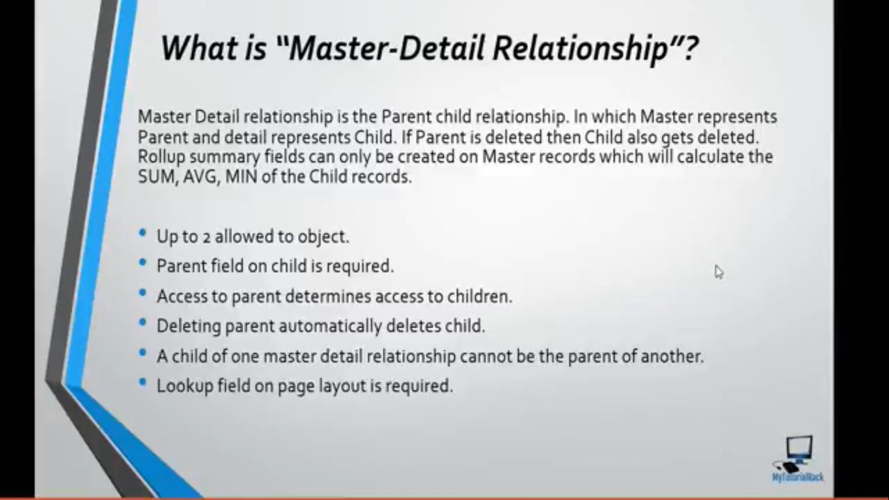

Its one-to-many relationship.

Its tightly coupled.

Rollup summary field can only be available on parent object.

We can create a master detail relationship between standard and custom object as long as the standard object on the master side.

We can create up to 2 master detail relationship for an object.

## How to create a Master detail relationship on a object containing records?

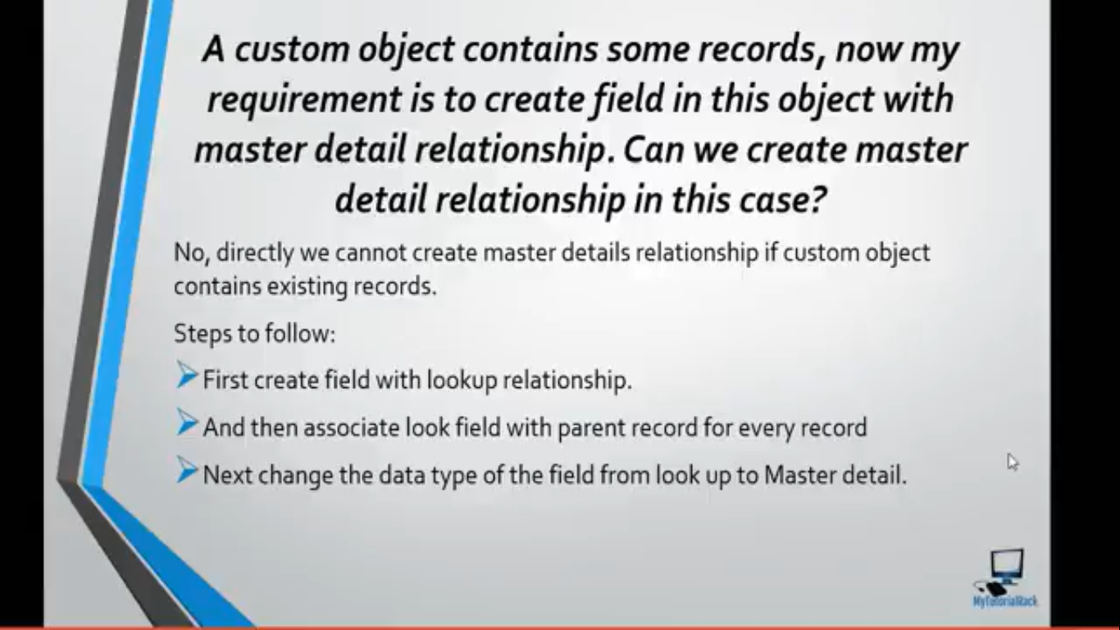

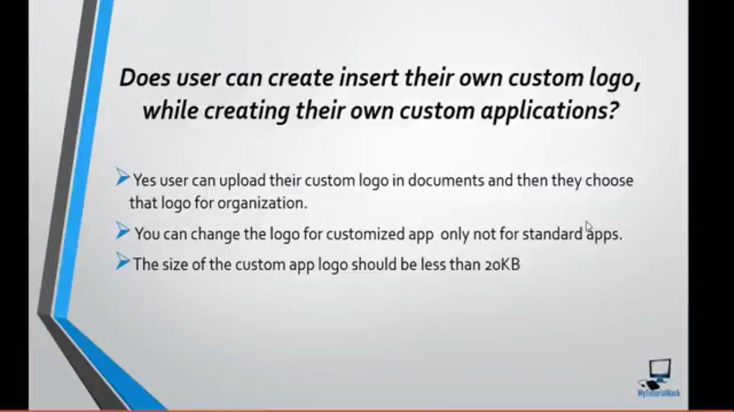

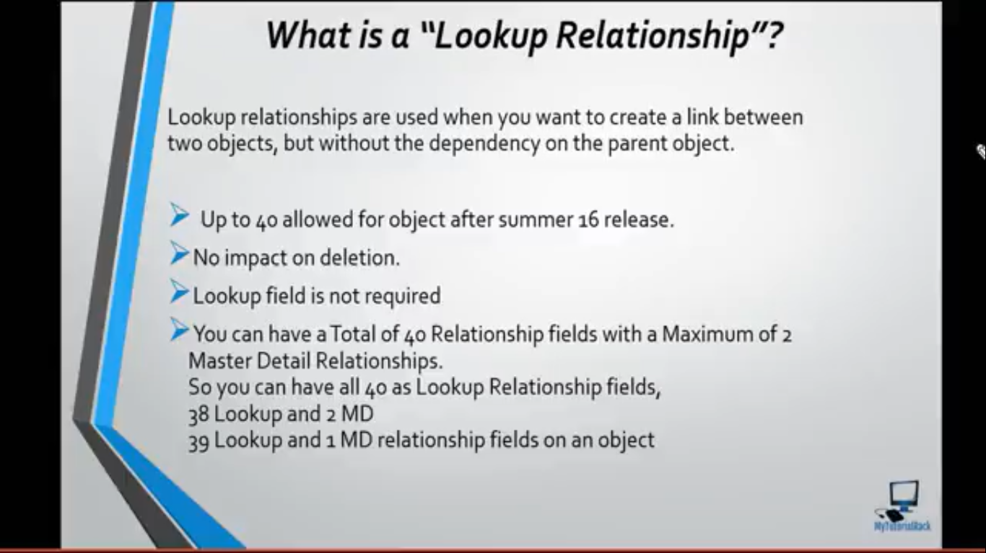

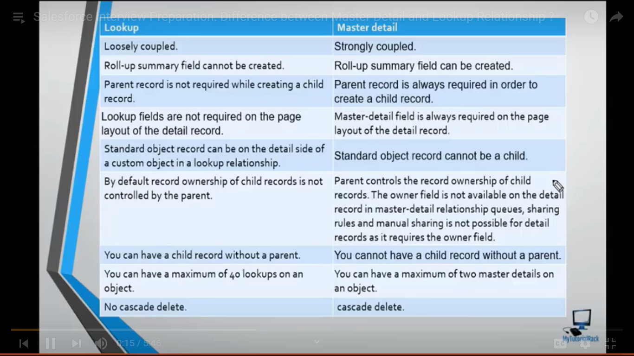

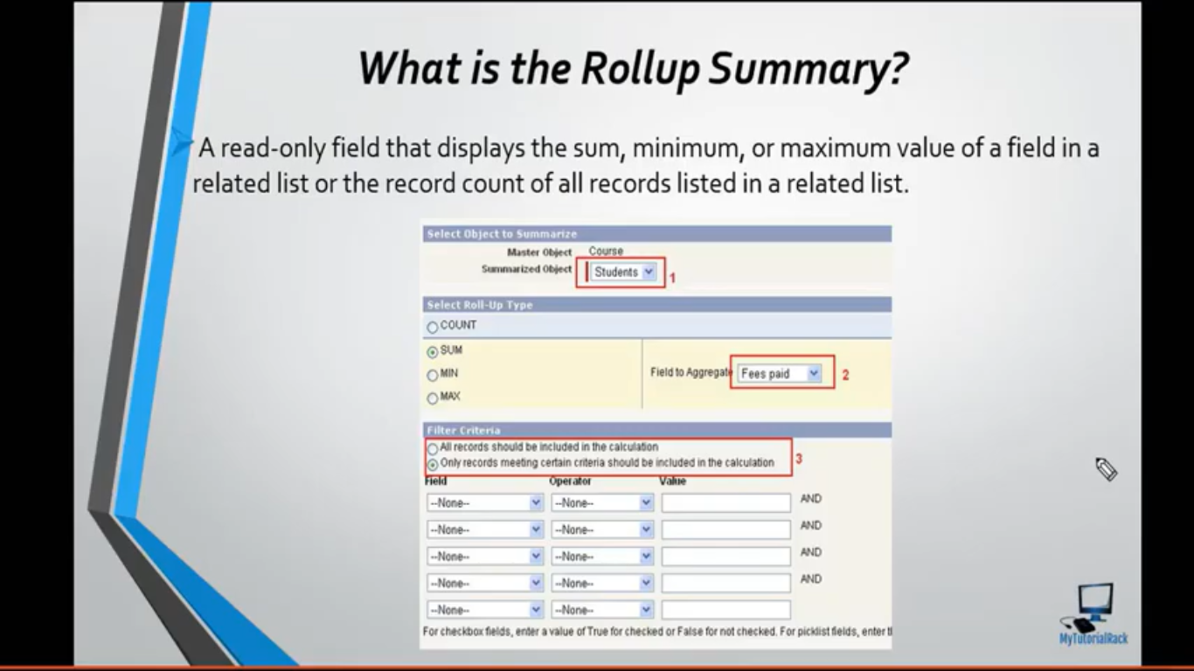

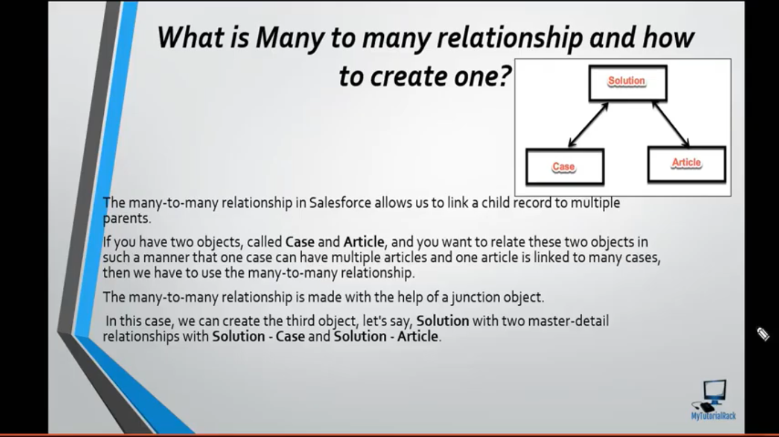

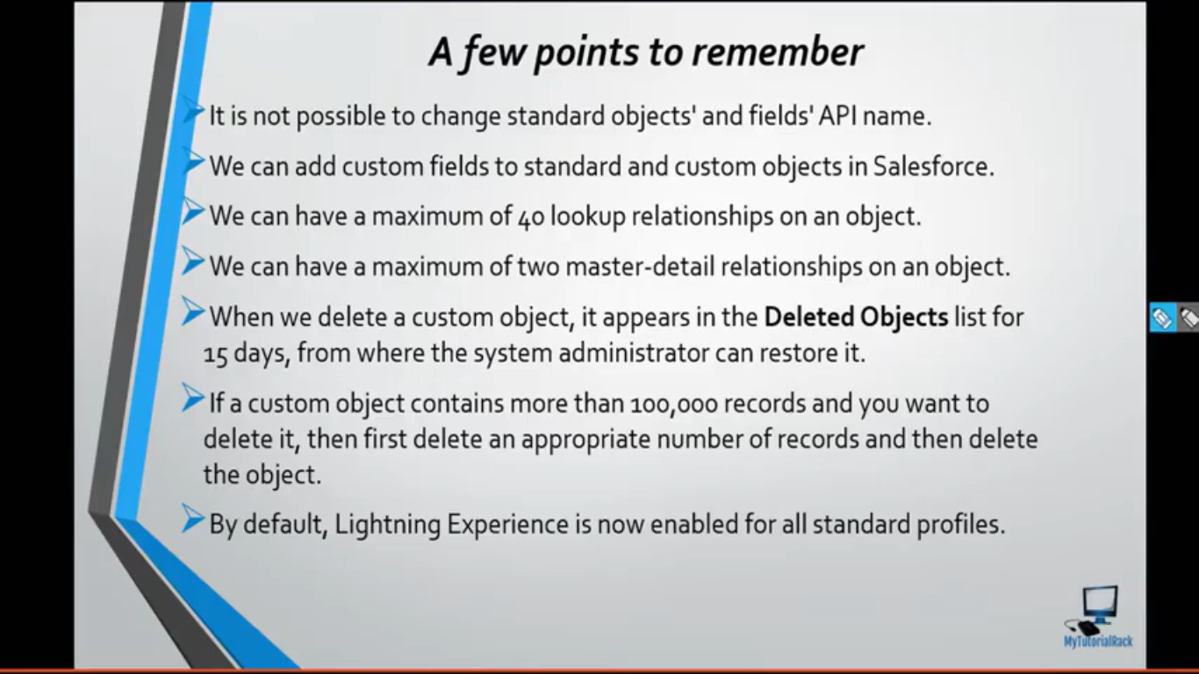

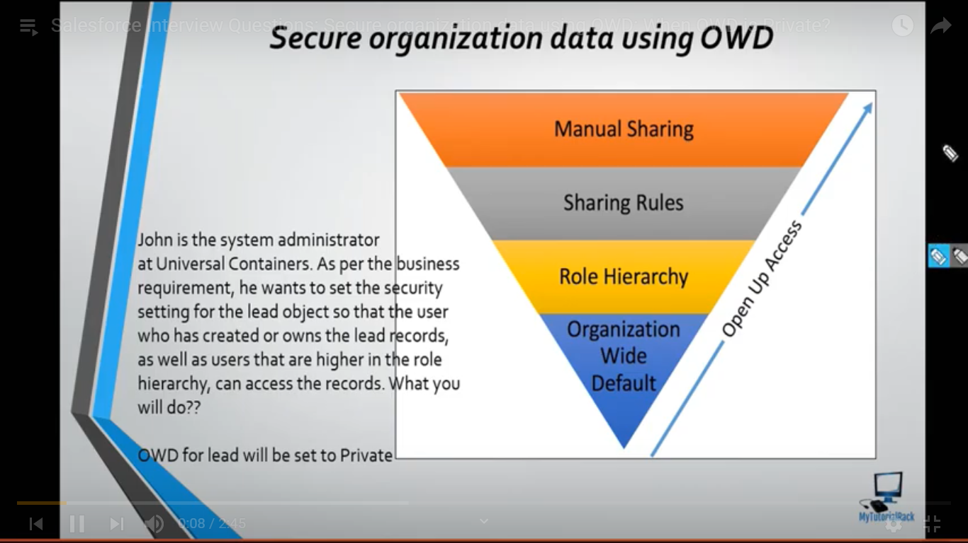

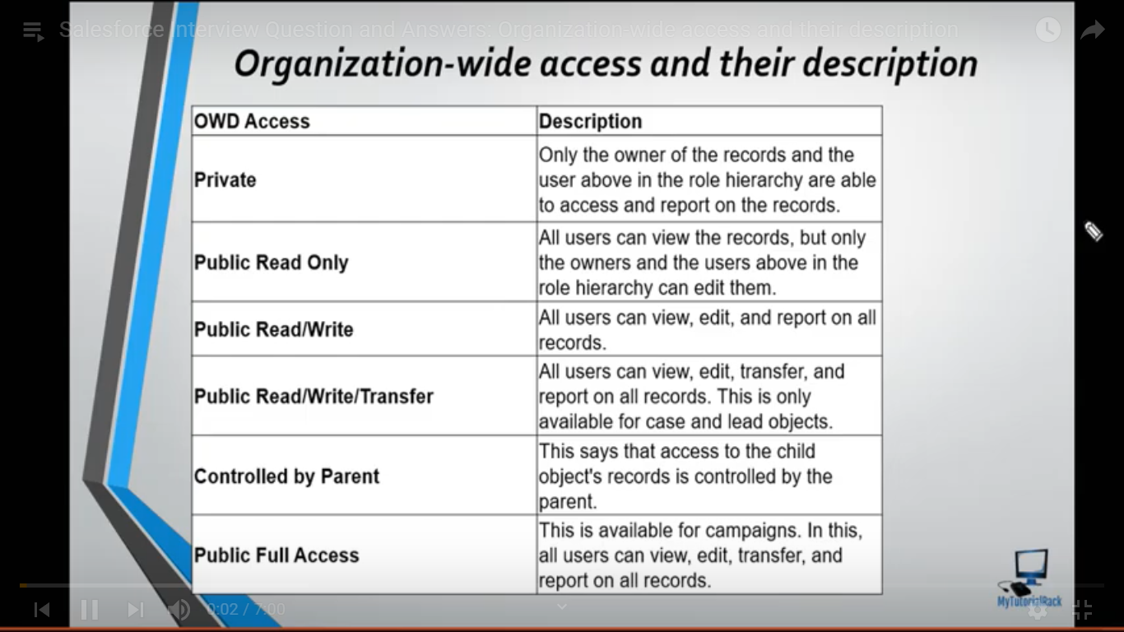

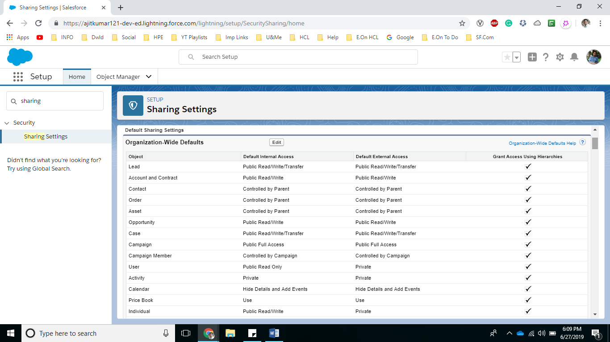

**Note:**

Public Read/Write/Transfer is only available for Lead and Case objects.

Grant Access Using Hierarchy field can only be unchecked for Custom Objects.

